**DAILY ONLINE ACTIVITIES SUMMARY**

|  |  |  |  |
| --- | --- | --- | --- |
| **Date:** | 23/06/2020 | **Name:** | Krishnitha |
| **Sem & Sec** | 4th sem, A Section | **USN:** | 4AL18CS039 |
| **Online Test Summary** | | | |
| **Subject** | NA | | |
| **Max. Marks** | NA | **Score** | NA |
| **Certification Course Summary** | | | |
| **Course** | Web Development Engineer | | |
| **Certificate Provider** | AWS Educate | **Duration:** | 3:30 hrs |
| **Coding Challenges** | | | |
| **Problem Statement:**  1) Python Program to Split the array and add the first part to the end There is a given an array and split it from a specified position, and move the first part of array add to the end.  2) Write a C Program to Sort a stack using a temporary stack. | | | |
| **Status:** Executed | | | |
| **Uploaded the report in GitHub** | | YES | |
| **If yes Repository name** | | <https://github.com/krishnitha/Python-coding>  <https://github.com/krishnitha/C-coding> | |
| **Uploaded the report in slack** | | YES | |

**Certification Course Details:**

Today I have started the new course “Web Development Engineer” by AWS Educate. In this course today I learnt about Introduction and about programming and scripting. And I have also completed the assessment of this module.

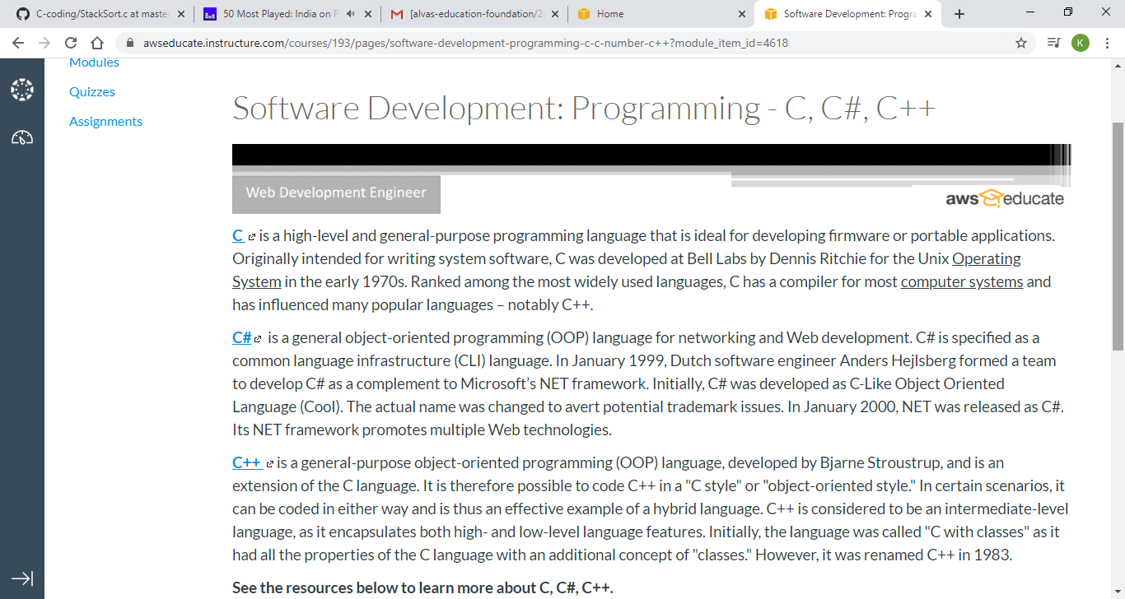

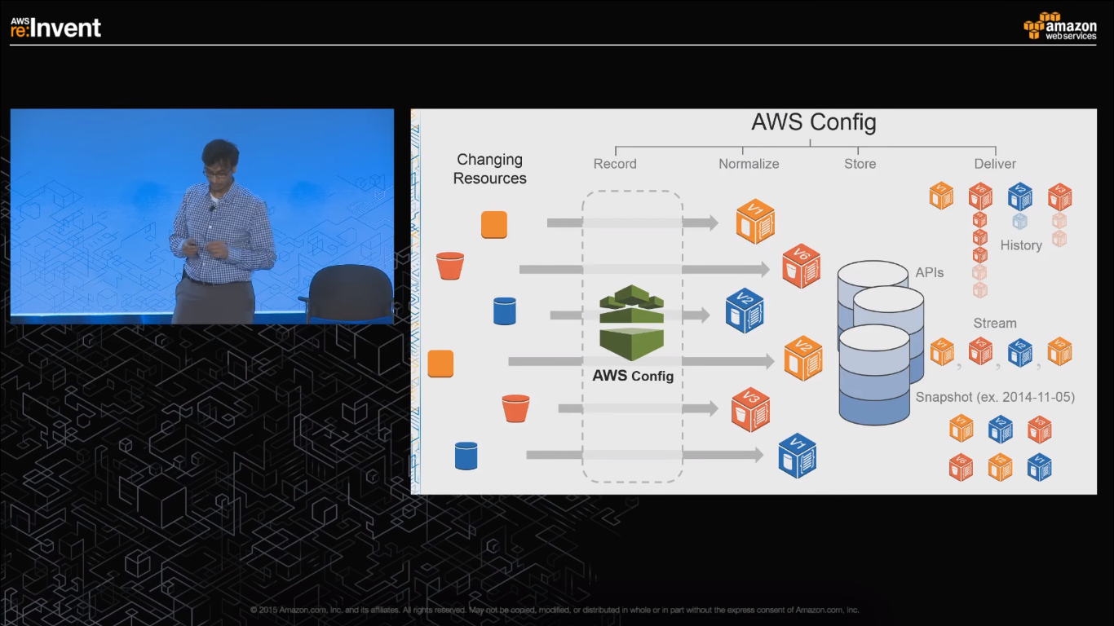

**Coding Challenges Details:**

**Problem 1:** Python Program to Split the array and add the first part to the end There is a given an array and split it from a specified position, and move the first part of array add to the end.

**Examples:**

Input : arr[] = {12, 10, 5, 6, 52, 36}  
k = 2  
Output : arr[] = {5, 6, 52, 36, 12, 10}  
Explanation : Split from index 2 and first  
part {12, 10} add to the end .

Input : arr[] = {3, 1, 2}  
k = 1  
Output : arr[] = {1, 2, 3}  
Explanation : Split from index 1 and first  
part add to the end.

## Solution: Uploaded it in GitHub

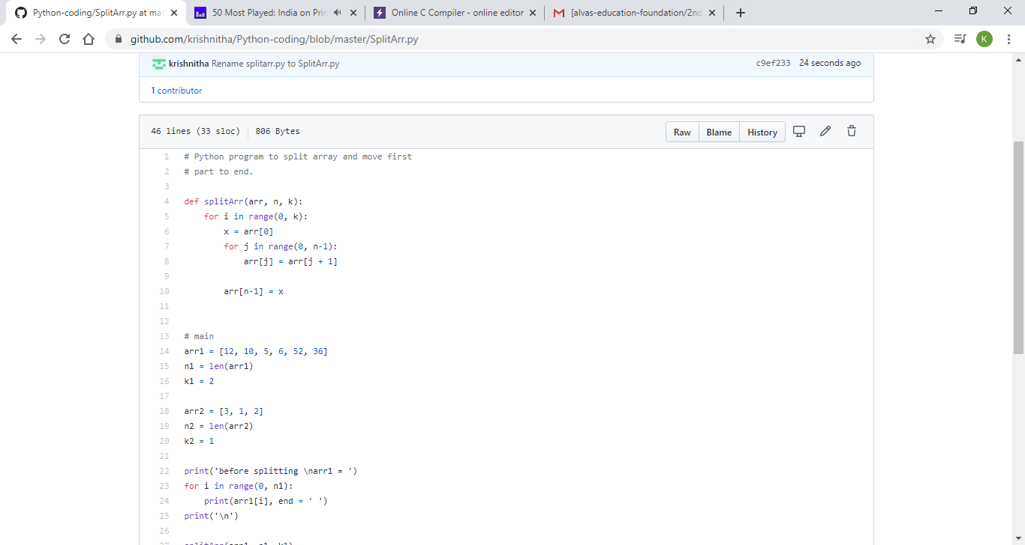

## Problem 2: Write a C Program to Sort a stack using a temporary stack.

We follow this algorithm.

1. Create a temporary stack say tmpStack.
2. While input stack is NOT empty do this:  
   • Pop an element from input stack call it temp  
   • while temporary stack is NOT empty and top of temporary stack is greater than temp,  
   pop from temporary stack and push it to the input stack  
   • push temp in temporary stack
3. The sorted numbers are in tmpStack

**Solution:** Uploaded it in GitHub

